The analysis of working capital indicators across the three firms reveals clear differences in liquidity management, operational efficiency, and short-term financial strategy over the period 2021–2023.
Firm A demonstrates a consistent improvement in working capital management. The current ratio increased steadily from 1.80 to 2.10,as shown in Figure 4.1, indicating strengthening liquidity and a growing capacity to meet short-term obligations. At the same time, receivable days declined from 45 to 40 days, suggesting more efficient credit control and faster cash conversion. Inventory turnover also improved from 5.2 to 6.1 times, reflecting better inventory management and reduced holding costs. Collectively, these trends indicate that Firm A is moving toward a more efficient and balanced working capital structure, where liquidity is maintained without sacrificing operational efficiency.
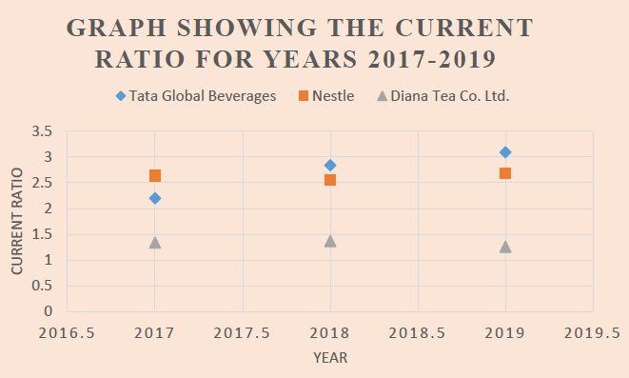
Figure 4.1 Current Ratio 2017-2019

In contrast, Firm B exhibits a relatively weaker and more constrained working capital position. Although the current ratio shows a modest increase (from 1.40 to 1.70), it remains lower than the other firms, suggesting tighter liquidity conditions. Receivable days remain relatively high, only decreasing from 55 to 50 days, as shown in Figure 4.2 below, which indicates slower collection cycles and potential inefficiencies in credit management. Additionally, payable days increased from 38 to 42 days, implying that the firm may be deliberately delaying payments to suppliers as a liquidity management strategy. While this may temporarily ease cash flow pressures, it may also signal underlying working capital constraints and could negatively affect supplier relationships.
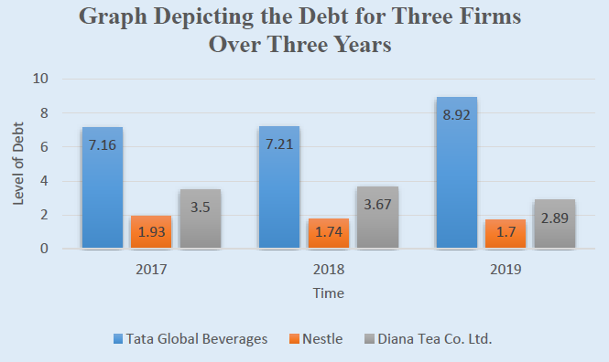
Figure 4.2 Debit Ratio 2017-2019
Firm C presents the strongest overall working capital performance, though with slight fluctuations. The current ratio remains consistently high (ranging from 2.10 to 2.30), indicating strong liquidity. Receivable days are the lowest among the firms (declining from 38 to 36 days), suggesting highly efficient credit collection processes. Inventory turnover is also the highest, increasing from 6.5 to 6.8 times, reflecting superior inventory management. However, the slight decline in the current ratio in 2022 before rising again in 2023 may indicate active working capital optimisation rather than inefficiency, where excess liquidity is being strategically utilised.
A cross-firm comparison highlights that Firm C maintains the most efficient working capital system, followed by Firm A, while Firm B lags behind. These findings are consistent with prior empirical studies which argue that efficient management of receivables and inventory is central to effective working capital performance. For instance, Deloof (2003) finds that firms with shorter collection periods and faster inventory turnover tend to manage working capital more efficiently, while Shin and Soenen (1998) emphasise the importance of minimising the cash conversion cycle to enhance operational efficiency.
Overall, the findings indicate that working capital management is dynamic and firm-specific, shaped by managerial policies and operational practices. The patterns observed here reinforce the broader literature, suggesting that firms which actively optimise liquidity and operational cycles are better positioned to achieve efficient working capital structures.

